SUBHAM KUNDU
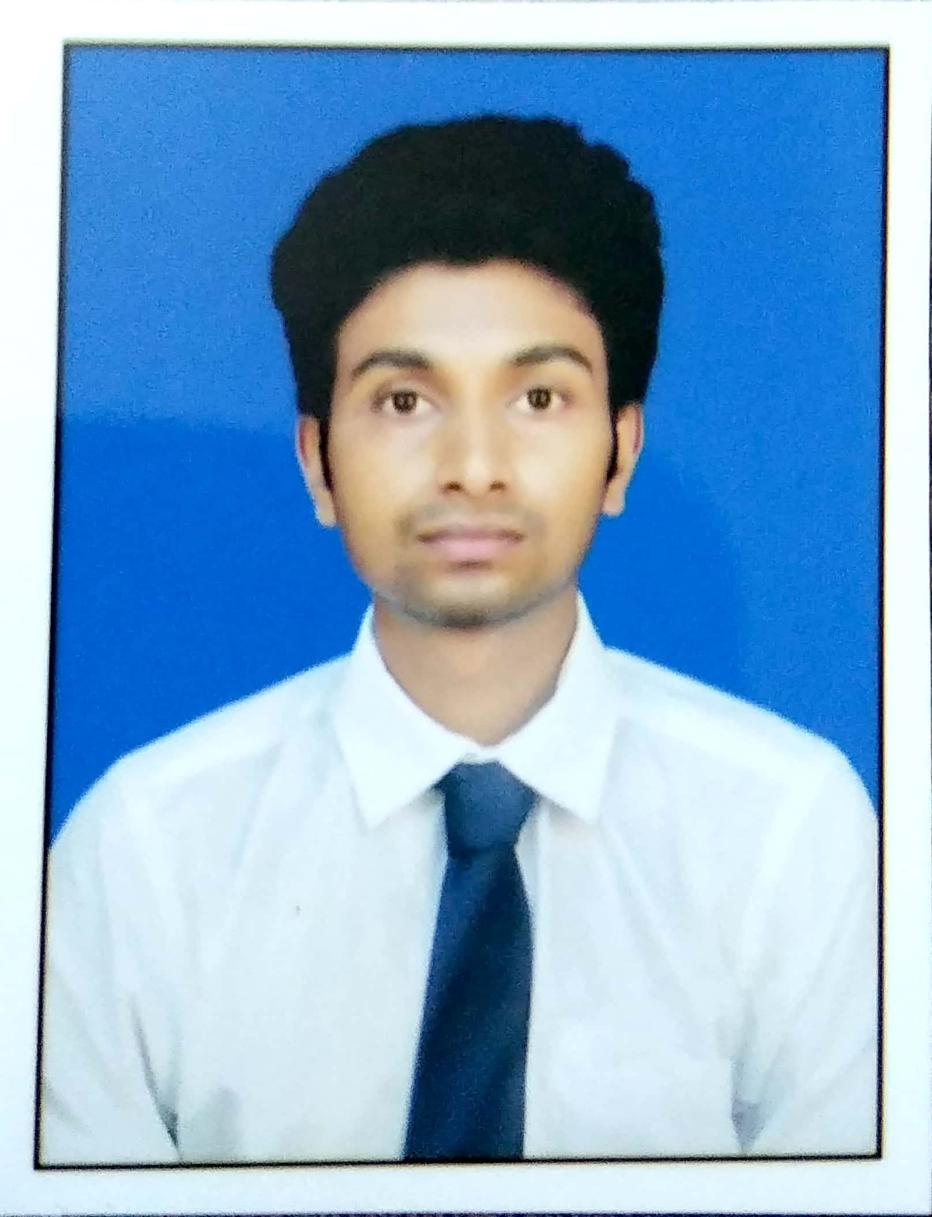
Contact: 8240681124
E-mail-kundusubham6291@gmail.com
Present sattus:MBA in Finance
Address:Kanchrapara,50 bazar road,Dist-North 24 pgs

CAREER OBJECTIVE

To work in an environment where I can apply and enhance my knowledge, skills to serve the organization to the best of my efforts and achieve a better career.

ACADEMIC QUALIFICATION
- MBA in Finance[Major]and Marketing [Minor]from Maulana Abdul Kalam University of Technology (2017 - 2019) with 1st year-YGPA 5.94,2nd year-YGPA 6.38
- B.COM(h) fromKalyani University with 44.12% (2013 -2016)
- Class XII (Commerce), WBCHSE Board(West Bengal Council of Higher ScondaryEducation)fromHarnett High Schoolwith64.00% (2011 – 2013)
- Class X, WBSE(West Bengal Board of Secondary Education)fromHarnett High Schoolwith61% (2011)
TECHNICAL SKILLS
MS-Outlook, MS-Word, MS-Excel (hands on experience)
SUMMER INTERNSHIP PROGRAMME
Project Title: Impact of NPA on Retail Banking.
Project duration: July 2018 to August 2018
Organization:Dena Bank
Area of Operation:Sealdah.
Project Description: Perform research on factors that impact the service quality in Retail banking sector specifically due to ineffective NPA policy. This also includes research on how retail bank works, retail banking trends and services offered by retails banking
Project Objectives:
- To study the Gross NPA% ratio of selected 10 Banks.
- To study the Net NPA% ratio of selected 10 banks.
- To provide a recommendation as how NPA issue can be managed.
Roles & Responsibilities:
- Collection of data for 10 selected banks.
- Analysis of data for the selected banks.
- Identifying potential solution for NPA issue.

PERSONAL QUALITIES
- Confident to resolve any issues using my analytical thought process.
- Believe in individual strength but have collaborative mindset.
- Disciplined approach to identify problems and solving them.
- Organized but flexible to adapt with changes.
- Effective communication skills.
ACHIEVEMENTS
- Organized College Management fest.
- Integrated an extremely complex system for the College.
EXTRA CURRICULAR ACTIVITIES
Quiz seminar and cultural activities
HOBBIES & INTERESTS
Hobbies:Cricket ,Travelling
Career Interests: Interested towards financial & operational kind jobs
PERSONAL DETAILS
DOB: 06-09-1994
Father’s Name: Rabin Kundu
Gender: Male
Marital Status: Single
Languages Known:English,Bengali,Hindi

Date:
Place:

SubhamKundu

